28th June 2013

Sanne Muurling
Kees Mandemakers

Data Description Brabant census data 1810

I Source description

The census of 1810 was a census ordered by the French authorities. During French rule (1806-1813) they introduced a governmental system based on the French one, dividing the Netherlands in several Départements and appointing several préfects and sous-préfects. The French authorities obliged the mayors (called maires) to provide information about a wide range of matters, among which is the data about the composition of the population. In 1811 this data has been collected in several provinces, like Zeeland, Brabant and Overijssel. Not all censuses have survived and they have not all recorded information in the same way. For example, the 1811 census of Overijssel only records that part of the population that was 18 years and over, while Brabant (like Zeeland) also records children. This allows for a more complete household reconstruction.

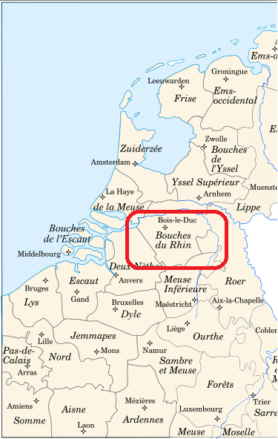
For the Brabant 1810 census, called the Etat de population, a standard form was used by all municipalities. This form is quite detailed and consistently records data such as civil status, the number of children, relationships and religion for all inhabitants. Both for standardisation purposes and comparability we have flagged variables that we have constructed from the original data with an x.

The census data for all municipalities except Tilburg has been entered into the database by volunteers from the Regionaal Historisch Centrum Eindhoven (RHC Eindhoven) who were kind enough to provide us a copy. The 1810 Tilburg census (from the archive Regionaal Archief Tilburg) has been digitized by dr. Elise van Nederveen Meerkerk (Wageningen University). We have cross-checked the data in the database with the original censuses for accuracy and completeness. The databases were not complete. This means that aside from correcting small errors, we spent considerable time supplementing the database with data not (consistently) digitized. In principal we have chosen to record the data from the original censuses as they are.
Figure 1. The division of Holland during French Rule 1811-1813. Brabant is marked red.

II List of municipalities

In the province of Brabant the 1810 censuses kept in the RHC Eindhoven have been preserved for 6 municipalities, all of which have been digitized. For the Regionaal Archief Tilburg, all preserved 1810 censuses have been scanned, but only the census of Tilburg is digitized (table 1).

Table 1. The number of records in Brabant’s 1810 censuses
Municipality | No. of records | % of 1795 | % of 1830 | % of 1840
Bladel | 1058 | 142.2 | Unknown | 175.5
Deurne | 2517 | 153.1 | Unknown | 147.6
Eindhoven | 2250 | 119.6 | 78.2 | 77.4
Geldrop | 1298 | 117.9 | Unknown | 74.9
Heeze | 1615 | 108.2 | Unknown | 93.4
Helmond | 2524 | 101.4 | Unknown | 55.5
Tilburg | 9679 | 113.4 | 82.5 | 68.9
Total | 20941

To determine if municipalities should be distinguished as urban or rural, we first looked at the list of municipalities that -as ‘cities having a vote’ (stemgerechtigde steden)- received the right to appoint representatives in the Dutch Provincial States in 1814. Ten of Brabant’s municipalities received this right: Bergen op Zoom, Geertruidenberg, Oosterhout, Breda, Tilburg, Heusden, Grave, ‘s-Hertogenbosch, Helmond and Eindhoven. We have cross-checked this with the categorization of urban and rural areas after 1849. Another (additional) criterion that is often used for this time is that the number of inhabitants is at least 2500, although for Brabant this does not always hold up. According to this understanding of urbanity, three of Brabant’s municipalities can be categorized as urban: Eindhoven, Helmond and Tilburg.

III Archival references

Table 2. Archival references of Brabant’s 1810 censuses (Etat de population)
Municipality | Archival reference
Bladel | Etat de population de la mairie de Bladel, 1810, Gemeentebestuur Bladel, arch.no. 10255, inv.no. 326A (Regionaal Historisch Centrum Eindhoven).
Deurne | Etat de population de la mairie de Deurne, 1810, Gemeentebestuur Deurne, arch.no. 13181, inv.no. 13251 (Regionaal Historisch Centrum Eindhoven).
Eindhoven | Etat de population de la mairie de Eindhoven, 1810, Gemeentebestuur Eindhoven, arch.no. 10245, inv.no. 254 (Regionaal Historisch Centrum Eindhoven).
Geldrop | Etat de population de la mairie de Geldrop, 1810, Gemeentebestuur Geldrop, arch.no. 10262, inv.no. 457 (Regionaal Historisch Centrum Eindhoven).
Heeze | Etat de population de la mairie de Heeze, 1810, Gemeentebestuur Geldrop, arch.no. 10263, inv.no. 1628 (Regionaal Historisch Centrum Eindhoven).
Helmond | Etat de population de la mairie de Helmond, 1810, Nieuw administratief archief van de gemeente Helmond 1810-1912, arch.no. 100, inv.no. 166 (Regionaal Historisch Centrum Eindhoven).
Tilburg | Etat de population de la mairie de Tilburg, 1810, Archief van het Gemeentebestuur van Tilburg 1810-1907, arch.no. 4, inv.no. 1275-1277 (Regionaal Archief Tilburg).

IV Variable description

The following table (table 3) comprises all variables included in the census tables. Distinctions between the original values in the census and our interpretations, standardizations and so on have been made through the names of the variables. Variables followed by the suffix ‘_o’ are original data as found in the source, variables with the suffix ‘_x’ are interpreted ones and variables with the suffix ‘_f’ are indicating the ways in which we have interpreted some specific data.
In the Brabant censuses of 1810 data household relationships were added to the columns of ‘last name’ and ‘occupation’. To keep things clear we made a separate variable for relationships with the suffix ‘_o’ for relation, although this does not mean that there was in fact a separate column in the census.
The census of 1811 was a pursuit of the French rulers. This means that in the original source, all data is written in French (except comments, which were sometimes added in Dutch). This is reflected in the occupational titles as well as civil status and relationships. In our database we want to capture the data as it is in the original census.
All Dutch municipalities are code with the so-called ‘Amsterdam-code’, which is the historical standard code for all Dutch municipalities existing from the 1st of January 1812 onwards (Ad van der Meer & Onno Boonstra, Repertorium van Nederlandse gemeenten 1812-2006 (DANS The Hague 2006). The latlon-references were provided by Nies Huijsmans (LIACS, Leiden Institute of Advanced Computer Science). ‘Unknown’ if a place or province or country could not be standardized.
Table 3. Variable description
Variable | Explanation
Id | Primary key (auto number).
Municipality_o | The municipality of the census.
Province_x | The province to which the municipality belongs.
Country_x | The country to which the municipality belongs.
District_o | The district number to which the person belongs.
Municipality_Adam_code | Amsterdam code for the municipality of the census
Municipality_lat | Latitude of centre of the municipality of the census (two digits)
Municipality_lon | Longitude of centre of the municipality of the census (two digits)
Urban_Rural_x | Urban or rural character of the municipality
 | Rural | Tilburg, Eindhoven and Helmond are considered as urban, for more information see the description of the sample.
 | Urban
Year_census_o | Year of the census.
Page_no_o | Page number of the person in the census.
Id_sequence_o | Identifier for the sequence established by this code is identical to the sequence number recorded in the census. Because this is related to the different censuses, there are recurring numbers for different municipalities.
Id_household_x | Household numbers as constructed according to the way the households are indicated in the source and the rules that have been used to distinguish different households as stated respectively in the following variables Household_source_f and Household_f. The numbering is unique per municipality.
Household_source_f | Flag assigned for how the households are distinguished (or not) in the source.
 | 1 | Persons are sequentially recorded in households, distinguished by house numbers and relationships and/or marital status which are explicitly included in the census.
 | 2 | Persons are sequentially recorded in households, distinguished by house numbers. No explicit relationships are distinguished in the census.
 | 3 | Persons are sequentially recorded in households, not distinguished by house numbers but are distinguished by defined relationships and/or marital status.
 | 4 | Persons are sequentially recorded in households, not distinguished by house number or defined relationship or marital status.
 | 5 | No explicit ordering in households to be discerned (e.g. in case of alphabetic ordering of the individuals).
Household_f | Flag assigned for the solution how households are determined (for the specification of the rules constructing the household identifier see appendix I):
 | 1 | Households are distinguished by explicitly given internal relationships.
 | 2 | Households are distinguished by house number
 | 3 | Households are distinguished by applying rules for household determination, rule 3.2. -3.6
 | 4 | Households are distinguished as an institution because of rule 3.7.1 – 3.7.3
Name_last_o | The surname of the individual as given by the source. If the name is unknown, ‘Unknown’ is added in the database.
Name_first_o | The first name of the individual as given by the source. If the name is unknown, ‘Unknown’ is added in the database.
Name_prefix_o | The prefix of the individual as given by the source.
Relation_o | The relation of the individual within the household, if given by the source.
Relation_x | Constructed value of the relationship in the household (construction, because the relationship was not always included in the source, for rules see variable Relation_f).  The relationship variables are assigned from the perspective of the household head and their spouse. For example, this means that the mother from the wife is assigned to ‘Extended family’.
 |  | Head
 |  | Wife
 |  | Child
 |  | Extended family
 |  | Co-resident
Relation_f | 32 | Head
 | 33 | Wife
 | 34 | Child
 | 35 | Extended family
 | 36 | Co-resident
 | 37 | Institution
Birth_date_o | The birth date as it is recorded in the source. Except for Tilburg, most censuses record the day, month and year is given, although occasionally only the month and year or only the year of birth is recorded. Sometimes only the age in years is given, which is recorded in its appropriate field (Age_o). In the case of Tilburg, often only the birth year is given, or the month and the year. Only sometimes the birth day is given. The data from this field is always recorded as dd-mm-yyyy. In this field missing data is indicated field by 00 (for example May 1771 is recorded as 00-05-1771).  The birth day, month and year are subdivided into Birth_day_x, Birth_month_x and Birth_year_x.
Birth_day_x | The day of birth as retrieved from Birth_date_o. Recorded as dd. If the data is missing from the source, this variable has been left blank.
Birth_month_x | The month of birth as retrieved from Birth_date_o. Recorded as mm. If the data is missing from the source, this variable has been left blank.
Birth_year_x | The year of birth as retrieved from Birth_date_o. Recorded as yyyy. If the data is missing from the source, this variable has been left blank.
Age_o | The age of the person as given by the source. If the person was born in the year of 1810, the age is recorded as ‘0’.  If the age is not given in the source, the field in the database is left empty.
Birth_place_o | The place of birth as given by the source. When this field is left blank in the source, we recorded this as ‘Unknown’.
Birth_place_x | Standardized place of birth.
Birth_municipality_x | Standardized name of municipality that includes location of place of birth
Birth_province_x | Standardized name of province that includes location of birth of birth
Birth_country_x | Standardized name of country that includes location of place of birth
Birth_place_Adam_code | Amsterdam code for municipality of birth
Birth_place_lat | Latitude of centre of the municipality of birth (two digits)
Birth_place_lon | Longitude of centre of the municipality of birth (two digits)
Sex_x | The sex of an individual:
 |  | Male
 |  | Female
 |  | Undetermined
Sex_f | Flag assigned on how the sec of a person was determined
 | 1 | Sex of person is derived from the relationship in the household
 | 2 | Sex of person is derived from first name
 | 3 | Sex of person is explicitly recorded in the source
Civil_status_o | The civil status of the individual as given by the source. Distinctions are made between ‘Pas marie’ (unmarried), ‘Marie’ (married), ‘Veuf’ (widower) and ‘Veuve’ (widow).  When the civil status is not given, the civil status is recorded as ‘Unknown’ (N=1).
No_of_children_o | The number of children as recorded in the source. Generally this number refers to the number of children living with the person, but sometimes it is used to refer to the total number of children unrelated to current cohabitation.  When the source does not list any number of children, the field is left blank. However, when one of the spouses does have children but the other one does not (for example when the children are from a previous marriage), a ‘0’ is recorded (like the source does).
Religion_o | The religion of the individual. Pre-printed options were: Catholique (Catholic), Protestant, Lutherien (Lutheran) and Juifs (Jewish). In one occasion another denomination was given by way of handwriting (Mennonite). If not given in the source, religion is recorded as Unknown (N=1).
Occupation_o | Occupation of the individual as given by the source. In the source this field is also used to record information about relationships, data which we have recorded into Relation_o.
Occupation_standard_x | Standardized version of the occupation (in Dutch).
HISCO | The HISCO code assigned to the standardized occupation recorded in Occupation_standard_x, see, M.H.D. van Leeuwen, I. Maas and A. Miles, HISCO. Historical International Standard Classification of Occupations (Leuven 2002).
HISCO_status | The additional code assigned to add the dimension of status to the HISCO (not always given), see further above.
OCCHISCO | HISCO code as used in the NAPP project
Comments_o | Comments recorded in the census. This variable is occasionally used to record information about how the person supported him or herself, or sporadically whether the person deceased or left the municipality. In the database, comments are generally recorded in Dutch
Source_info_x | The archive reference where the source can be found.
Appendix 1. Rules for making household variables

The Dutch 1811 censuses are rich historical sources that are documented per household. In the Brabant censuses all of these censuses contain explicit information about relationships (wife, son, daughter, brother, sister, granddaughter, orphan and so on), civil status and the number of children.

In order to distinguish household structures from the data we have constructed rules. These rules are based on the method described in Gruber, Scholz and Szoltysek article ‘Real and synthetic household populations and their analysis. An example of early historical census microdata (Rostock in 1819)’. Unlike the Rostock microdata, the Zeeland censuses are generally reported in a uniform household sequence of head, wife, children, servants, co-residents and so on, although variations do occur. To benefit the most from the reported structure we have expanded the set of rules to incorporate and capture this reported sequence if possible.

A household may consist of one or more persons. Special cases are institutions like hospitals, boarding schools or poor houses, which are also viewed as a(n institutional) household (see rule 3.7).

In determining households, page ordering is of no use because most of the censuses were filled from top to bottom. With special variables (flags) we indicate how we have constructed the household and the relationships.

I Sources with explicitly given house numbers
- Persons with the same house number are assumed to be in the same household. A house number was given in fourteen villages out of a total of 26 (including Goes). Distinguishing everyone on one house number as one household means that there is a risk that persons are seen as boarders while in fact they have their own entrance in the house. This may also lead to two families being grouped into one household.

II Sources without explicitly given house numbers
- In villages without explicitly given house numbers households have to be deduced from the composition of a group of persons. This presupposes that persons are included in the census register in order of a household sequence and that the special roles in the household may be distinguished (see rules 3.1 to 3.7). This has the consequence that boarders may be categorized as households on their own.

III. Rules to determine relationships in a household (and defining the limits of a household)

- Basics assumptions behind interpreting household composition:
  - In case relationships and/or marital status are made explicit, for example wife, son or daughter, we take this value instead of using a rule.
  - If head of households are not made explicit, they can be recognized by:
    - Being the first person in a sequence of numbered households (in case when the house numbers are given in the source);
    - Being a male over 18 years old and being recognized as part of a marriage (see rule 3.3);
    - Being over 18 years old and having children (younger persons with the same last name, in case of a female last names will differ, see rule 3.4) ;
    - Being a person over 36 years old listed first in a sequence not clearly related to the previous household and sharing the same last name as other following but younger persons in the source over 18 years of age (either their adult children or other relatives).
  - Marriage of 2 persons: The second person in the census household is assumed to be the wife of the head of the household in case the person is a female, be explicitly married or having a different last name than the head of the household (and should not be explicitly divorced or unmarried), be over 15 years old.
  - Children: Other persons are assumed to be children of the head of the household if they are explicitly referred to as child, daughter or son, and/or have the same last name as the potential father and have an age difference of at least 15 and at most 46 years with the potential mother (and 55 for a potential father by lacking a mother). When a widow is the head of the households, more than one person with the same (but different from the mother’s) last name in that household that have an age difference of at least 15 and at most 46 years with the potential mother are considered to be children as well.
  - Other related household members: In case persons with the same last name as the head of the household or their spouse differ less than 15 years of age or in case they are older than the head or their spouse they are supposed to be relatives if they have the same last name of the head or the wife of the head. The family of the relative is also assigned to the previous household.
  - Other non-related household members: Persons are assigned to the household when:
    - Their occupational title belongs to the list of occupational titles indicating co-residence (e.g. servant, apprentice, journeyman) and the person is unmarried;
    - The relationship to the household head is consistent with this occupation;
    - The occupational title is similar to the previous one, and the person is not married;
    - The person is unmarried and below the age of 20 years; The person is an unmarried woman below the age of 25 years;
    - The person is an unmarried woman between the ages of 20 and 39 years, and there is no occupational information about her.
    - The person is an unmarried or widowed women above the age of 40, and there is no occupational information about her and the relationship to the previous and next household is unclear (no recurring last name, no explicit information about relationships).
  - Institutions are recognized by
3.7.1 Having a head with typical occupations like ‘Boarding house holder’, ‘School teacher’, ‘Poor house father’ etc., followed by a series of unrelated last names.
3.7.2 Having a specific title in the address or name, indicating an institutional setting
3.7.3 Having a special place in the census book.

Appendix 2. Photographs of Brabant censuses of 1810

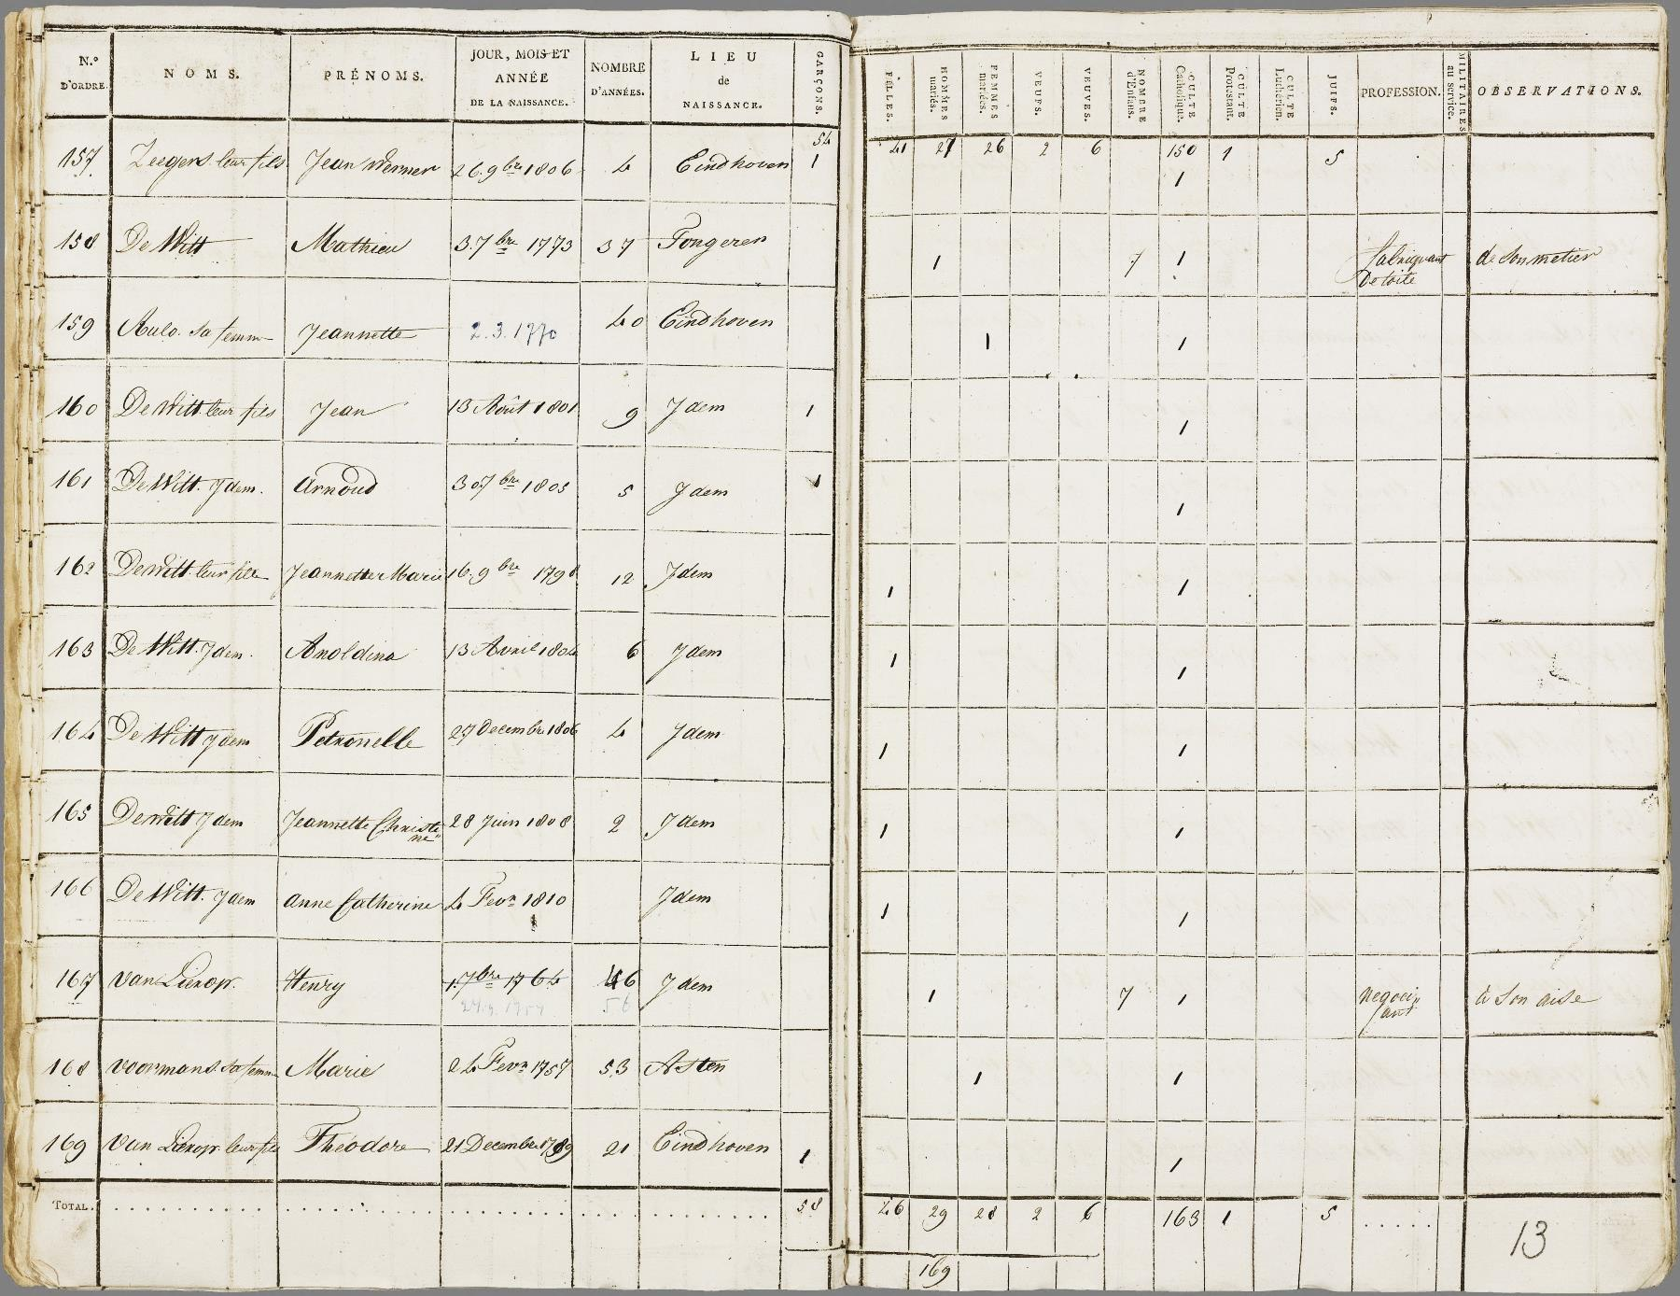
Figure 2. The 1810 census of Eindhoven, page 13.

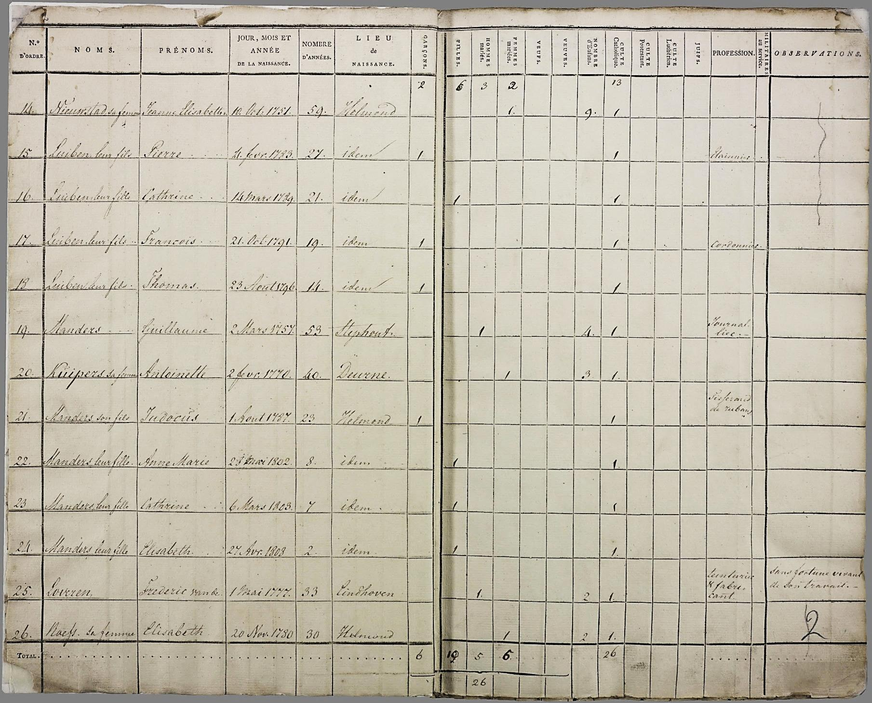
Figure 3. The Helmond census of 1810, page 2.

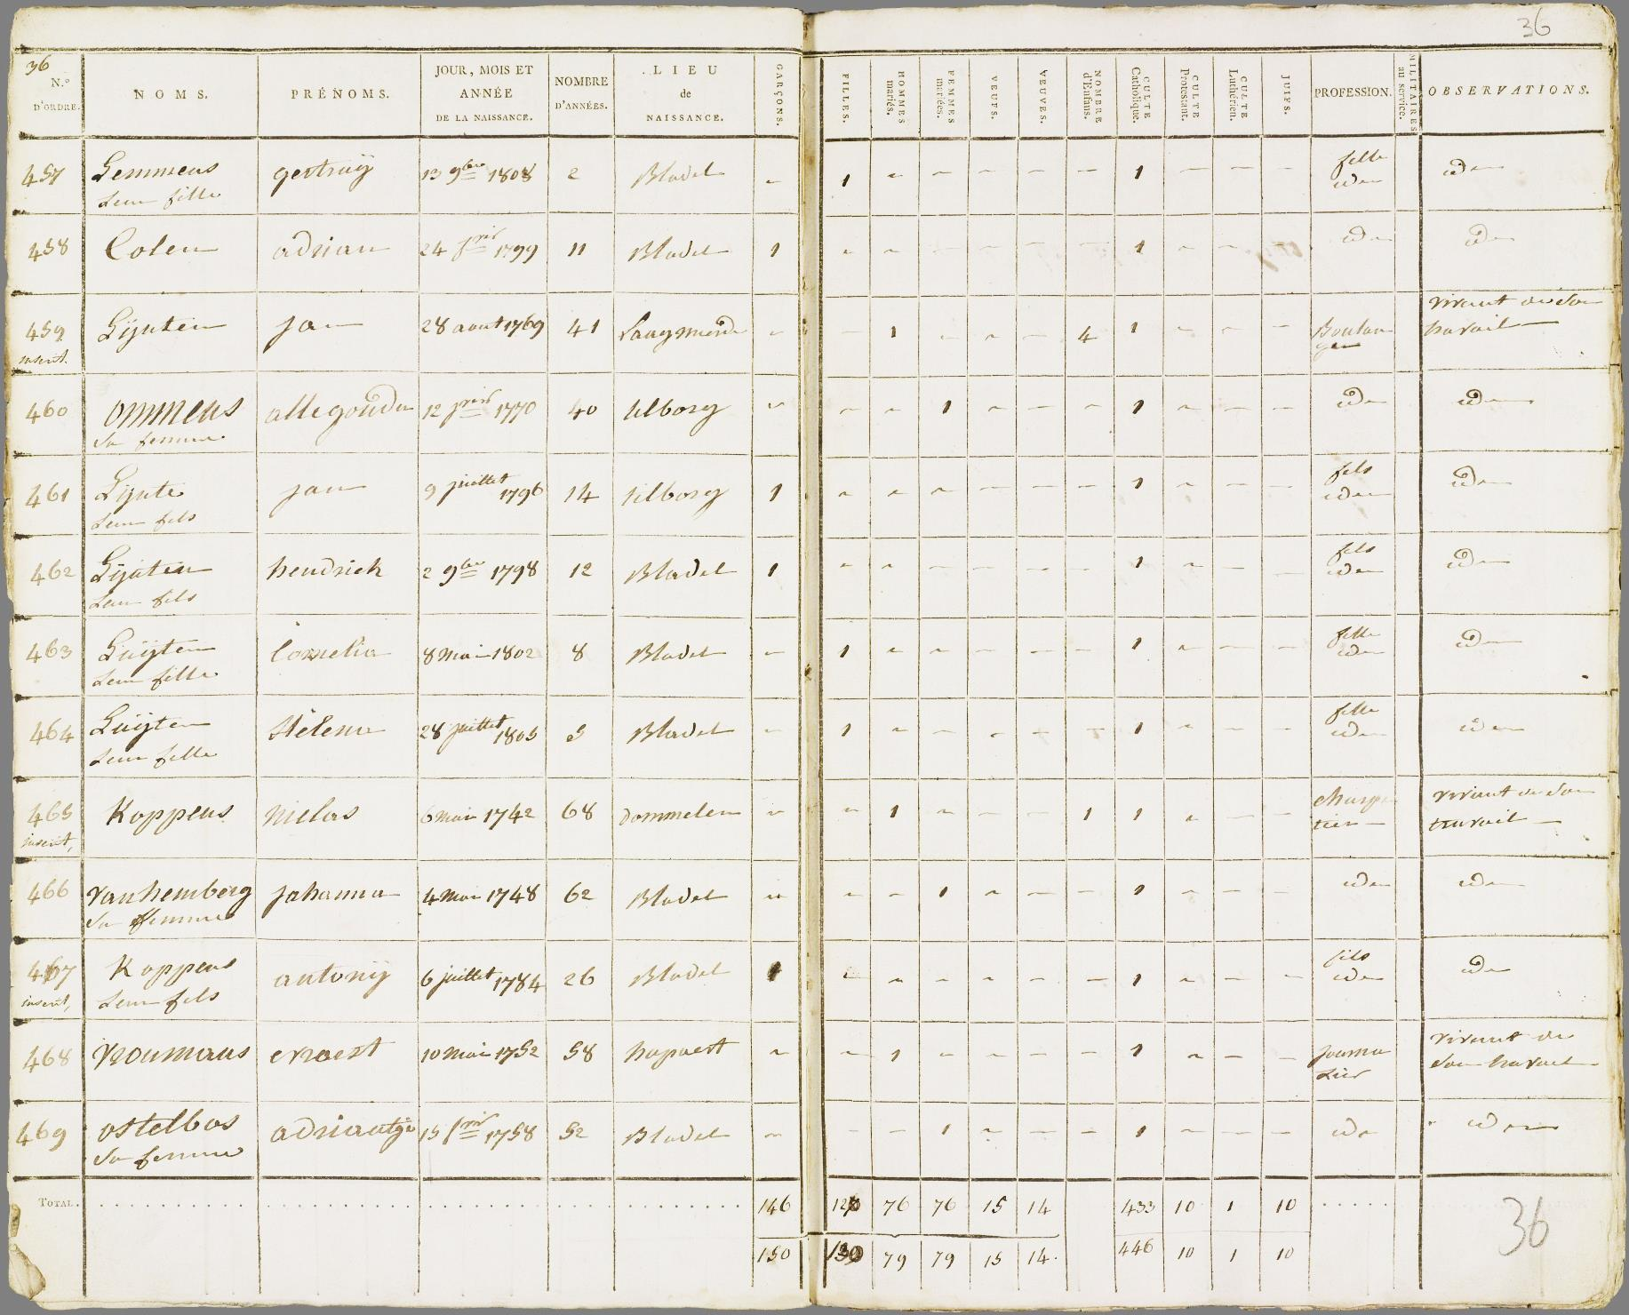
Figure 4. The 1810 census of Bladel, page 36.

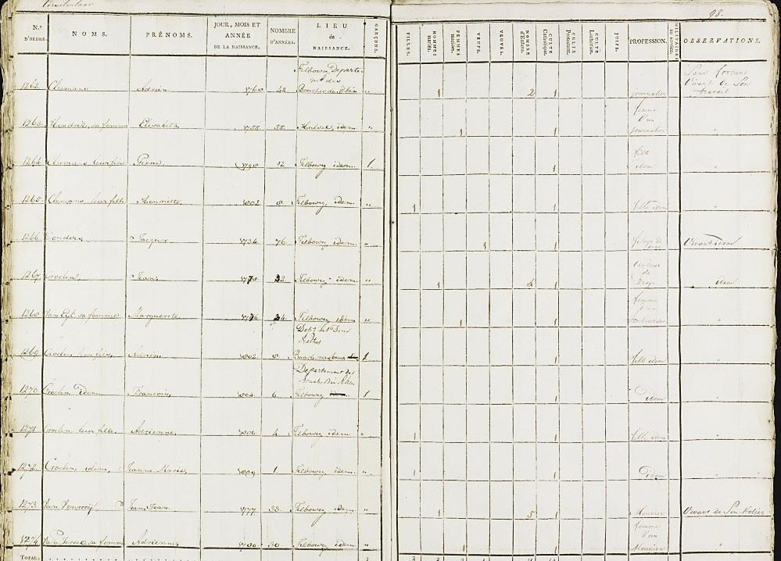
Figure 5. The 1810 census of Tilburg, page 98.

Reglement omtrent de samenstelling van de Staten der provincies, resp. het Landschap Drenthe (Koninklijk Besluit 6 April 1814). The entire list of municipalities that received this right: Groningen, Leeuwarden, Franeker, Dokkum, Harlingen, Sneek, Bolsward, IJlst, Sloten, Workum, Hindeloopen, Stavoren, Assen, Coevorden, Meppel, Zwolle, Kampen, Deventer, Hattem, Elburg, Harderwijk, Nijkerk, Zutphen, Lochem, Groenlo, Arnhem, Doesburg, Doetinchem, Wageningen, Nijmegen, Bommel (Zaltbommel), Tiel, Kuilenborg (Culemborg), Utrecht, Wijk, Rhenen, IJsselstein, Montfoort, Amersfoort, Weesp, Amsterdam, Monnickendam, Edam, Enkhuizen, Hoorn, Medemblik, Alkmaar, Purmerende, Zaandam, Haarlem, Leyden, Woerden, Gouda, ’s-Gravenhage, Delft, Schoonhoven, Schiedam, Maassluis, Brielle, Vlaardingen, Gorinchem, Dordrecht, Rotterdam, Zierikzee, Veere, Middelburg, Vlissingen, Goes, Sluis, Axel, Hulst, Tholen, Willemstad, Bergen op Zoom, Geertruidenberg, Oosterhout, Breda, Tilburg, Heusden, Grave, ’s-Hertogenbosch, Helmond, Eindhoven, Venlo en Maastricht. Helmond lost its right in 1815. In 1818 Weert was added.
M.C. Deurloo and G.A. Hoekveld, ‘The population growth of the urban municipalities in the Netherlands between 1849 and 1970, with particular reference to the period 1899-1930’, in: H. Schmal (ed.), Patterns of European urbanization since 1500 (London 1981)249-283.
S. Gruber, R.D. Scholz and M. Szoltysek, ‘Real and synthetic household populations and their analysis. An example of early historical census microdata (Rostock in 1819)’, Historical Methods 44:2 (2011) 107-113.

